Literacy support worksheet

1.1 Science is the study of the natural and physical world

Pages 2–3 and 170

What is science?

1 Look at the different types of scientists in the box below. Match each type of scientist to the situation they would be best able to investigate.

• Pharmacologist • Meteorologist • Environmental scientist

• Palaeontologist • Marine biologist • Nanotechnologist

a A species of coral living in the Great Barrier Reef is dying unexpectedly.

b A fossilised ancient kangaroo has been discovered in the Simpson Desert.

c An area of the Wilson’s Promontory National Park is drying out because of climate change.

d There is a possible tropical cyclone threat to northern Queensland.

e A drug is needed to treat a new strain of the Avian Bird Flu that has reached Australia.

f A scientific theory that viruses could generate electricity needs to be researched.

2 Describe what the scientist in the photograph might be doing.

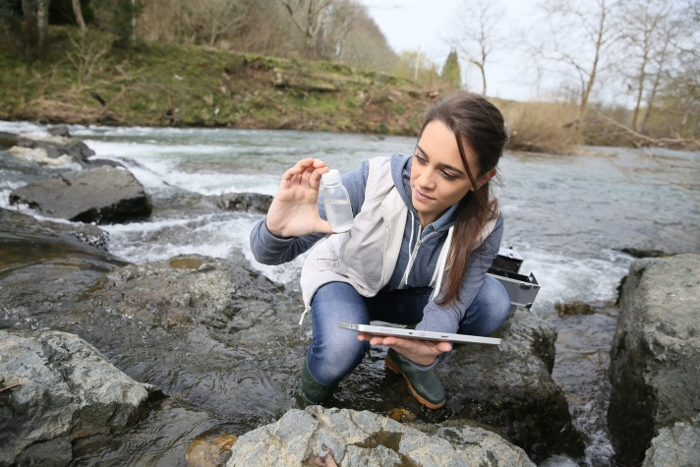

WORD DETECTIVE

3 Crossword

Read the clues below and complete the crossword.

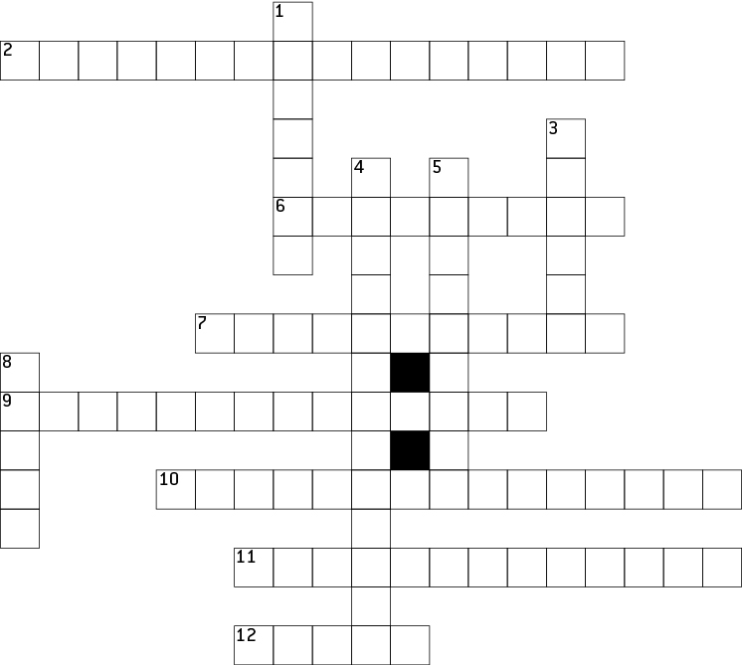

**CLUES**

|  |  |
| --- | --- |
| **Across** | **Down** |
| 2 A scientist who studies substances at the atomic level  6 A branch of science that involves chemicals  7 A lover of knowledge  9 A scientist who studies medicines and drugs  10 A scientist who studies ancient life, including fossils  11 The type of scientist who studies the environment  12 The branch of science that studies soil, rocks and mud | 1 The branch of science that studies how things work  3 The type of scientist who studies life in the oceans and seas  4 A scientist who studies the atmosphere and the weather  5 A scientist who studies biology  8 The branch of science that studies the planets, stars and universe. |

Literacy support worksheet

1.2 Scientists use specialised equipment

Pages 4–5 and 171

Lab equipment

This worksheet could be completed as a quiz or you could use it to revise the various types of specialised equipment used in the science laboratory.

1 Below are a series of scientific diagrams. Write the name of the scientific equipment and a short description of how the equipment is used next to the diagram in the space provided.

|  |  |  |
| --- | --- | --- |
| a | WS0105_00883-r_v2 | Equipment: \_\_\_\_\_\_\_\_\_\_\_\_\_\_\_\_\_\_\_\_\_\_\_\_\_\_\_\_\_\_\_\_\_\_\_  Used for: \_\_\_\_\_\_\_\_\_\_\_\_\_\_\_\_\_\_\_\_\_\_\_\_\_\_\_\_\_\_\_\_\_\_\_ |
| b | WS0106_00883-r | Equipment: \_\_\_\_\_\_\_\_\_\_\_\_\_\_\_\_\_\_\_\_\_\_\_\_\_\_\_\_\_\_\_\_\_\_\_  Used for: \_\_\_\_\_\_\_\_\_\_\_\_\_\_\_\_\_\_\_\_\_\_\_\_\_\_\_\_\_\_\_\_\_\_\_ |
| c | WS0107_00883-r | Equipment: \_\_\_\_\_\_\_\_\_\_\_\_\_\_\_\_\_\_\_\_\_\_\_\_\_\_\_\_\_\_\_\_\_\_\_  Used for: \_\_\_\_\_\_\_\_\_\_\_\_\_\_\_\_\_\_\_\_\_\_\_\_\_\_\_\_\_\_\_\_\_\_\_ |
| d | WS0108_00883-r | Equipment: \_\_\_\_\_\_\_\_\_\_\_\_\_\_\_\_\_\_\_\_\_\_\_\_\_\_\_\_\_\_\_\_\_\_\_  Used for: \_\_\_\_\_\_\_\_\_\_\_\_\_\_\_\_\_\_\_\_\_\_\_\_\_\_\_\_\_\_\_\_\_\_\_ |
| e | WS0109_00883-r | Equipment: \_\_\_\_\_\_\_\_\_\_\_\_\_\_\_\_\_\_\_\_\_\_\_\_\_\_\_\_\_\_\_\_\_\_\_  Used for: \_\_\_\_\_\_\_\_\_\_\_\_\_\_\_\_\_\_\_\_\_\_\_\_\_\_\_\_\_\_\_\_\_\_\_ |
| f | WS0110_00883-r | Equipment: \_\_\_\_\_\_\_\_\_\_\_\_\_\_\_\_\_\_\_\_\_\_\_\_\_\_\_\_\_\_\_\_\_\_\_  Used for: \_\_\_\_\_\_\_\_\_\_\_\_\_\_\_\_\_\_\_\_\_\_\_\_\_\_\_\_\_\_\_\_\_\_\_ |
| g | WS0111_00883-r | Equipment: \_\_\_\_\_\_\_\_\_\_\_\_\_\_\_\_\_\_\_\_\_\_\_\_\_\_\_\_\_\_\_\_\_\_\_  Used for: \_\_\_\_\_\_\_\_\_\_\_\_\_\_\_\_\_\_\_\_\_\_\_\_\_\_\_\_\_\_\_\_\_\_\_ |

WORD DETECTIVE

2 Match-a-word

Match the following words with the relevant pictures

|  |  |
| --- | --- |
| Filter funnel | WS0121_00883-r |
| Tripod stand | WS0112_00883-r |
| Test tube rack | WS0117_00883-r |
| Spatula | WS0113_00883-r |
| Metal tongs | WS0114_00883-r |
| Thermometer | WS0115_00883-r |
| Evaporating dish | WS0116_00883-r |
| Conical flask | WS0118_00883-r |
| Test tube | WS0119_00883-r |
| Test tube holder | WS0120_00883-r |

Literacy support worksheet

1.3 Scientists take safety precautions

Pages 6–7

Safety in the lab

1 Read the dot points on what happened in the laboratory and write ‘do’ or ‘don’t’ next to each one.

• Connie listened carefully to her teacher explaining the experiment \_\_\_\_\_\_\_\_\_\_\_\_\_\_\_\_\_\_

• Rod put his earphones in while the teacher was explaining \_\_\_\_\_\_\_\_\_\_\_\_\_\_\_\_\_\_

• Rod put on his lab coat, but didn’t button it up \_\_\_\_\_\_\_\_\_\_\_\_\_\_\_\_\_\_

• Connie didn’t put on a lab coat because it didn’t match her outfit \_\_\_\_\_\_\_\_\_\_\_\_\_\_\_\_\_\_

• Connie didn’t tie her hair back \_\_\_\_\_\_\_\_\_\_\_\_\_\_\_\_\_\_

• Both of them wore safety glasses \_\_\_\_\_\_\_\_\_\_\_\_\_\_\_\_\_\_

• They put their textbooks under their desk \_\_\_\_\_\_\_\_\_\_\_\_\_\_\_\_\_\_

• They left their workbooks on the desk \_\_\_\_\_\_\_\_\_\_\_\_\_\_\_\_\_\_

• They put the Bunsen burner, tripod and gauze mat onto a bench mat \_\_\_\_\_\_\_\_\_\_\_\_\_\_\_\_\_\_

• They put the Bunsen Burner next to the gauze mat \_\_\_\_\_\_\_\_\_\_\_\_\_\_\_\_\_\_

• They lit the Bunsen Burner then walked away and chatted to friends \_\_\_\_\_\_\_\_\_\_\_\_\_\_\_\_\_\_

• Rod accidentally knocked the beaker on the floor and told his teacher \_\_\_\_\_\_\_\_\_\_\_\_\_\_\_\_\_\_

• They put the equipment away while it was still warm and burned their hands \_\_\_\_\_\_\_\_\_\_\_

• Connie washed her hands afterwards \_\_\_\_\_\_\_\_\_\_\_\_\_\_\_\_\_\_

• Rod forgot to wash his hands \_\_\_\_\_\_\_\_\_\_\_\_\_\_\_\_\_\_

• They put their coats away \_\_\_\_\_\_\_\_\_\_\_\_\_\_\_\_\_\_

• They left their safety glasses on the bench \_\_\_\_\_\_\_\_\_\_\_\_\_\_\_\_\_\_

2 This symbol means that corrosive materials such as acids and bases are present. What do you think the picture is of?



3 Why would it be needed in a science laboratory?

WORD DETECTIVE

4 True or false?

Read each statement below and circle T if it is true or F if it is false.

a Disposable gloves need to be worn during experiments T or F

b Gases or mixtures of chemicals need to be smelled when experimenting T or F

c Laboratory coats need to be worn at knee length T or F

d Safety glasses always need to be worn when mixing chemicals T or F

e Sandals can be worn when doing experiments T or F

f It doesn’t matter how your hair is worn when experimenting T or F

g Matches, paper and other substances need to go down the sink T or F

h Eating is not allowed in the laboratory T or F

i Vulcanologists wear heat-resistant silver suits T or F

j Chemicals are often mixed at random when experimenting T or F

Now make up some true or false questions for a friend.

Literacy support worksheet

1.4 Scientists use observation and inference to answer questions

Pages 8–9 and 172

Observation and inference

1 Beside each of the following observations, write the symbols QL (for qualitative observation) or QT (for quantitative observation).

a The liquid was very hot: \_\_\_\_\_\_\_\_\_\_\_\_

b The mouse was 4.5 centimetres long: \_\_\_\_\_\_\_\_\_\_\_\_

c The ball was travelling at 1 metre per second down the slope: \_\_\_\_\_\_\_\_\_\_\_\_

d I heard the chemicals fizzing: \_\_\_\_\_\_\_\_\_\_\_\_

e It took 6.7 seconds for the metal to dissolve: \_\_\_\_\_\_\_\_\_\_\_\_

f The chemical reaction caused a 76.3°C increase in temperature: \_\_\_\_\_\_\_\_\_\_\_\_

g I could smell the sulphur dioxide during the experiment: \_\_\_\_\_\_\_\_\_\_\_\_

h The surface of the bench felt rough: \_\_\_\_\_\_\_\_\_\_\_\_

i The substance turned blue when it was heated over the Bunsen burner: \_\_\_\_\_\_\_\_\_\_\_\_

j The 50 millilitres of water evaporated from the beaker: \_\_\_\_\_\_\_\_\_\_\_\_

2 What are two reasons why you should not smell things in a test tube unless your teacher instructs you to?

3 Here is a picture of Dr Redback and his family. Write ‘O’ for observations (facts) or ‘I’ for inference (likely explanation) next to each of the statements.

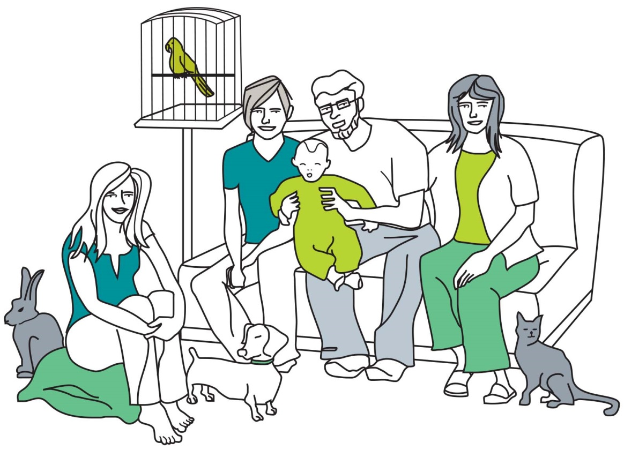

a One person is sitting on a pillow on the floor: \_\_\_\_\_\_\_\_\_\_\_\_

b There is a bird in the bird cage: \_\_\_\_\_\_\_\_\_\_\_\_

c The cat’s name is Mr Fluffy: \_\_\_\_\_\_\_\_\_\_\_\_

d The family is watching television: \_\_\_\_\_\_\_\_\_\_\_\_

e There are five people in the picture: \_\_\_\_\_\_\_\_\_\_\_\_

f Dr Redback is probably holding his grandson: \_\_\_\_\_\_\_\_\_\_\_\_

WORD DETECTIVE

4 Secret message

Use words from the student book to work out the secret message below:

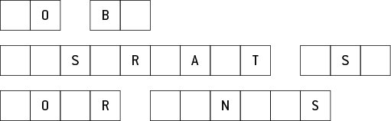

Literacy support worksheet

1.5 Science relies on measuring with accuracy

Pages 10–13 and 172

Measuring in the lab

1 Rearrange the letters of each of the words below to work out what is being measured.

a sams \_\_\_\_\_\_\_\_\_\_\_\_\_\_\_\_\_\_\_\_\_\_\_\_\_\_\_\_\_\_\_\_\_\_\_\_\_\_\_\_\_\_\_\_\_\_\_\_\_\_\_\_\_\_\_\_

b tereprmueat \_\_\_\_\_\_\_\_\_\_\_\_\_\_\_\_\_\_\_\_\_\_\_\_\_\_\_\_\_\_\_\_\_\_\_\_\_\_\_\_\_\_\_\_\_\_\_\_\_\_\_\_\_\_\_\_

c dntcsaei \_\_\_\_\_\_\_\_\_\_\_\_\_\_\_\_\_\_\_\_\_\_\_\_\_\_\_\_\_\_\_\_\_\_\_\_\_\_\_\_\_\_\_\_\_\_\_\_\_\_\_\_\_\_\_\_

d uvelmo \_\_\_\_\_\_\_\_\_\_\_\_\_\_\_\_\_\_\_\_\_\_\_\_\_\_\_\_\_\_\_\_\_\_\_\_\_\_\_\_\_\_\_\_\_\_\_\_\_\_\_\_\_\_\_\_

e emit \_\_\_\_\_\_\_\_\_\_\_\_\_\_\_\_\_\_\_\_\_\_\_\_\_\_\_\_\_\_\_\_\_\_\_\_\_\_\_\_\_\_\_\_\_\_\_\_\_\_\_\_\_\_\_\_

2 Use the clues below to determine the unit of measurement.

a Equal to 100 cm \_\_\_\_\_\_\_\_\_\_\_\_\_\_\_\_\_\_\_\_\_\_\_\_\_\_\_\_\_\_\_\_\_\_\_\_\_\_\_\_\_\_\_\_\_\_\_\_\_\_\_\_

b ‘Not’ spelled backwards \_\_\_\_\_\_\_\_\_\_\_\_\_\_\_\_\_\_\_\_\_\_\_\_\_\_\_\_\_\_\_\_\_\_\_\_\_\_\_\_\_\_\_\_\_\_\_\_\_

c I came first, she came third, you came where? \_\_\_\_\_\_\_\_\_\_\_\_\_\_\_\_\_\_\_\_\_\_\_\_\_\_\_\_\_\_\_\_

d 100 of these are equal to 1 metre \_\_\_\_\_\_\_\_\_\_\_\_\_\_\_\_\_\_\_\_\_\_\_\_\_\_\_\_\_\_\_\_\_\_\_\_\_\_\_\_\_\_

e 60 minutes worth \_\_\_\_\_\_\_\_\_\_\_\_\_\_\_\_\_\_\_\_\_\_\_\_\_\_\_\_\_\_\_\_\_\_\_\_\_\_\_\_\_\_\_\_\_\_\_\_\_\_\_\_\_

f Measurement inside the word ‘grammar’ \_\_\_\_\_\_\_\_\_\_\_\_\_\_\_\_\_\_\_\_\_\_\_\_\_\_\_\_\_\_\_\_\_\_\_\_\_\_

g Un-jumble the underlined words: the tiler relit the flame: \_\_\_\_\_\_\_\_\_\_\_\_\_\_\_\_\_\_\_\_\_\_\_\_\_

h This unit sounds like ‘cagey’ \_\_\_\_\_\_\_\_\_\_\_\_\_\_\_\_\_\_\_\_\_\_\_\_\_\_\_\_\_\_\_\_\_\_\_\_\_\_\_\_\_\_\_\_

i This unit sounds like ‘degrease’ and tends to heat up \_\_\_\_\_\_\_\_\_\_\_\_\_\_\_\_\_\_\_\_\_\_\_\_\_\_\_\_

WORRD DETECTIVE

3 Word search

Find as many words as possible in the puzzle below.

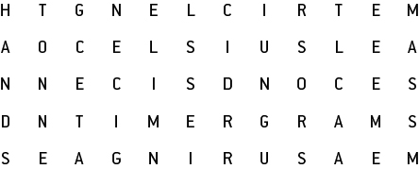

Literacy support worksheet

1.6 A Bunsen burner is an essential piece of equipment

Pages 14–15

Bunsen burners

1 Fill in the labels for the two Bunsen burner diagrams from the list below.

• Air hole open

• Air hole closed

• Heating flame

• Safety flame

Draw and colour in the flames in either blue or yellow.

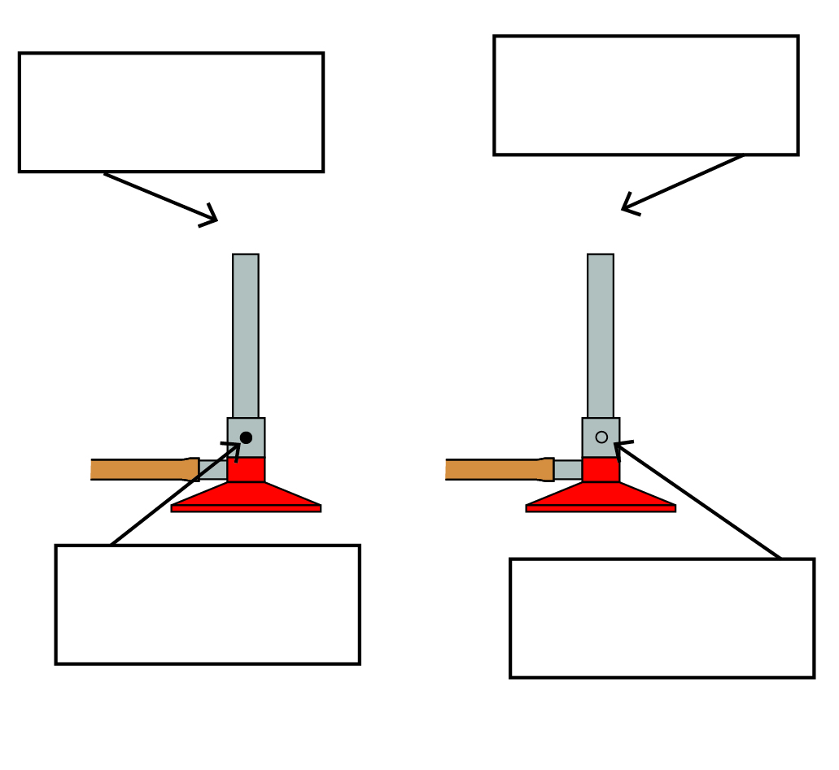

2 Write the numbers 1 to 6 next to the descriptions below so that the steps for lighting a Bunsen Burner are in order.

• Open the gas tap fully. \_\_\_\_\_\_\_

• Light a match and place it above the barrel, with your hand below the flame. \_\_\_\_\_\_\_

• Connect the rubber hosing firmly to the gas tap. \_\_\_\_\_\_\_

• Place the Bunsen burner on a heating mat. \_\_\_\_\_\_\_

• After you have followed these steps, the Bunsen burner will have a yellow flame. \_\_\_\_\_\_\_

• Close the air hole by turning the collar. \_\_\_\_\_\_\_

3 LPG is naturally odourless (you cannot smell it).

a Why do you think the gas supply companies add substances like hydrogen sulphide (rotten egg gas) to the LPG?

b What are two potential risks if the gas company did not add a smell to LPG?

WORD DETECTIVE

4 Mumbo-jumbo

a Use the marked letters to find the secret word (e.g. olusntoi = solution).

b Unscramble each of the clue words below to find the message.

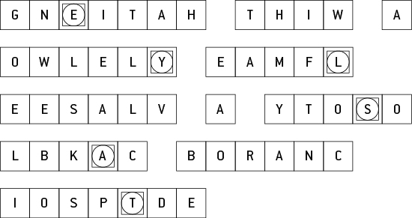

Secret word: \_\_\_\_\_\_\_\_\_\_\_\_\_\_\_\_\_\_\_\_\_\_\_\_\_\_\_\_\_\_\_\_\_\_\_\_\_\_\_\_\_\_\_\_\_\_\_\_\_\_\_\_\_\_\_\_\_\_\_\_\_\_\_\_\_\_\_\_\_\_\_\_\_\_

Message: \_\_\_\_\_\_\_\_\_\_\_\_\_\_\_\_\_\_\_\_\_\_\_\_\_\_\_\_\_\_\_\_\_\_\_\_\_\_\_\_\_\_\_\_\_\_\_\_\_\_\_\_\_\_\_\_\_\_\_\_\_\_\_\_\_\_\_\_\_\_\_\_\_\_\_\_

Literacy support worksheet

1.7 A fair test is a controlled experiment

Pages16–17

Controls

1 Read the dot points below describing an experiment and answer the questions.

• Sue wanted to know what coloured shirt would keep her coolest

• She thought lighter colours would work best because her Mum’s white car was cooler inside than her Dad’s black car

• Sue found five coloured squares of cloth: white, purple, red, black, yellow and green

• She put the squares of cloth on the trampoline on a sunny day

• Sue put a thermometer under each cloth

• She recorded the initial temperature of the five thermometers

• Sue waited 5 minutes and wrote down the temperatures

• She repeated the experiment three more times and recorded the results.

a What was Sue’s hypothesis?

b What was the independent variable in Sue’s experiment?

c What was the dependent variable in Sue’s experiment?

d What variables were controlled in Sue’s investigation?

e How did Sue attempt to improve the reliability of her investigation?

f Was Sue’s experiment a fair test? Why or why not?

g How could Sue’s experiment be improved so her results are more reliable?

WORD DETECTIVE

2 Draw and label

Draw and label Sue’s experiment using the following words:

independent variable dependant variable position of cloths time thermometers Sun

|  |
| --- |
|  |

Literacy support worksheet

1.8 Graphs and tables are used to show results

Pages18–21 and 173

Displaying results

1 Use the data in the results table to complete an appropriate graph in the space provided.

Change in water temperature over time

|  |  |
| --- | --- |
| Time (minutes) | Temperature (°C) |
| 5 | 43 |
| 10 | 37 |
| 15 | 35 |
| 20 | 24 |

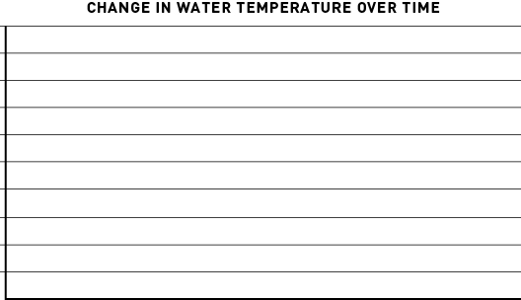

a What is the dependent variable?

b What is the independent variable?

2 Look at the graph below and answer the following questions.

a What type of graph is this?

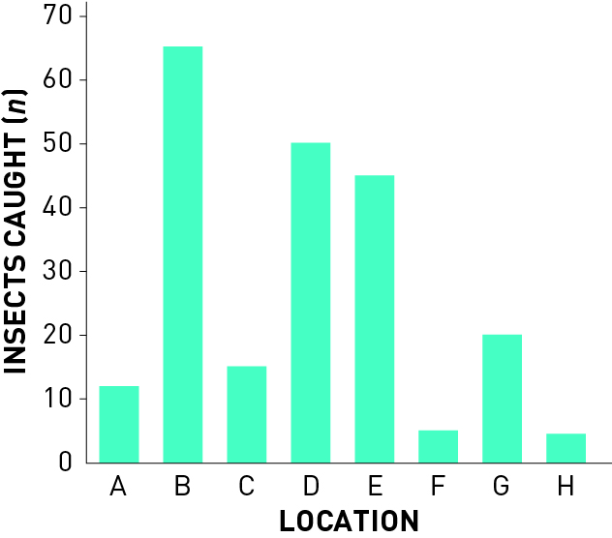

b Write a good title for this graph.

c What is the dependent variable?

d What is the independent variable?

e Which location had the highest number of insects caught?

f Which location had the lowest number of insects caught?

WORD DETECTIVE

3 Quick quiz

Answer the following questions using the list of words below:

column table discrete scatter continuous

a What type of data can only be whole numbers? \_\_\_\_\_\_\_\_\_\_\_\_\_\_\_\_\_

b What kind of graph is usually used to show discrete data? \_\_\_\_\_\_\_\_\_\_\_\_\_\_\_\_\_

c What type of data is the recording of times (e.g. for a 100 m race)? \_\_\_\_\_\_\_\_\_\_\_\_\_\_

d What kind of graph should be used to show continuous data? \_\_\_\_\_\_\_\_\_\_\_\_\_\_\_\_\_

e Besides a graph, what is another good way to show data? \_\_\_\_\_\_\_\_\_\_\_\_\_\_\_\_\_

Literacy support worksheet

1.9 Scientific reports communicate findings

Pages 22–23

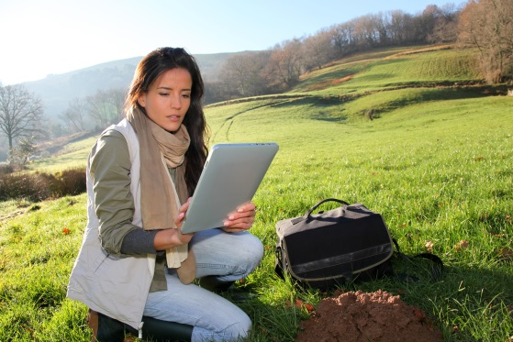Reporting

1 Trying to remember the eight parts of a scientific report can be a challenge at first.  
  
One way to remember the order is to create a mnemonic (using the first letter of each word to create new words to form a sentence).  
  
For example, ‘*Tiny Ants Healed Moths Meanwhile Rats Drew Cats’*, where ‘tiny’ is for ‘title’, ‘ants’ is for ‘aim’, and so on.

Write your own mnemonic next to the eights parts of a scientific report listed below:

a Title: \_\_\_\_\_\_\_\_\_\_\_\_\_\_\_\_\_\_\_\_\_\_\_\_\_\_\_\_\_\_\_\_\_\_\_\_\_\_\_\_\_\_\_\_\_\_\_\_\_\_\_\_\_\_\_\_

b Aim: \_\_\_\_\_\_\_\_\_\_\_\_\_\_\_\_\_\_\_\_\_\_\_\_\_\_\_\_\_\_\_\_\_\_\_\_\_\_\_\_\_\_\_\_\_\_\_\_\_\_\_\_\_\_\_\_

c Hypothesis: \_\_\_\_\_\_\_\_\_\_\_\_\_\_\_\_\_\_\_\_\_\_\_\_\_\_\_\_\_\_\_\_\_\_\_\_\_\_\_\_\_\_\_\_\_\_\_\_\_\_\_\_\_\_\_\_

d Materials: \_\_\_\_\_\_\_\_\_\_\_\_\_\_\_\_\_\_\_\_\_\_\_\_\_\_\_\_\_\_\_\_\_\_\_\_\_\_\_\_\_\_\_\_\_\_\_\_\_\_\_\_\_\_\_\_

e Method: \_\_\_\_\_\_\_\_\_\_\_\_\_\_\_\_\_\_\_\_\_\_\_\_\_\_\_\_\_\_\_\_\_\_\_\_\_\_\_\_\_\_\_\_\_\_\_\_\_\_\_\_\_\_\_\_

f Results: \_\_\_\_\_\_\_\_\_\_\_\_\_\_\_\_\_\_\_\_\_\_\_\_\_\_\_\_\_\_\_\_\_\_\_\_\_\_\_\_\_\_\_\_\_\_\_\_\_\_\_\_\_\_\_\_

g Discussion: \_\_\_\_\_\_\_\_\_\_\_\_\_\_\_\_\_\_\_\_\_\_\_\_\_\_\_\_\_\_\_\_\_\_\_\_\_\_\_\_\_\_\_\_\_\_\_\_\_\_\_\_\_\_\_\_

h Conclusion: \_\_\_\_\_\_\_\_\_\_\_\_\_\_\_\_\_\_\_\_\_\_\_\_\_\_\_\_\_\_\_\_\_\_\_\_\_\_\_\_\_\_\_\_\_\_\_\_\_\_\_\_\_\_\_\_

2 What are two different ways of writing the method?

WORD DETECTIVE

3 Match-a-word

Draw a line from the word to its meaning

Results Talking about what was found, problems faced and possible improvements

Hypothesis Your prediction about what will happen in the experiment

Scientific language States whether the goal (aim) was reached or not

Conclusion Represented in a table or graph

Method Your prediction about the result

Aim The write-up of the steps you did

Report Language used when writing a scientific report

Discussion The writing up of an experiment

Literacy support worksheet

1.10 Science skills are used to solve important problems

Pages 24–25

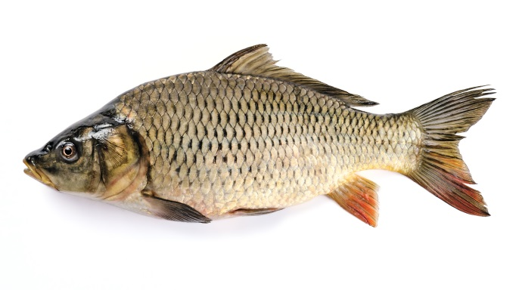Human endeavour

Cane toads are not the only introduced species that has caused major environmental issues in Australia.

European carp have also been introduced into Australia. It is believed that carp have destructive feeding habits that can have harmful effects on:

• aquatic plants

• animals

• general river health.

Carp are often found in degraded areas of rivers, although it is not clear whether they cause the degradation or are simply able to survive in degraded areas where native fish cannot.

1 Design a simple experiment that scientists could conduct now that could investigate methods to control the population of carp in the waterways of the Murray–Darling Basin. Use pages 16 and 17 in the textbook to help you.

a What is the aim of your experiment?

b What are three ‘what if’ questions you could ask yourself before starting the experiment? (Think about location, methods to control the carp and predators.)

c Write a hypothesis based on one of your three questions.

If \_\_\_\_\_\_\_\_\_\_\_\_\_\_\_\_\_\_\_\_\_\_\_\_\_\_\_\_\_\_\_\_\_\_\_\_\_\_\_\_\_\_\_\_\_\_\_\_\_\_\_\_\_\_\_\_\_\_\_\_\_\_\_\_\_\_\_\_\_\_\_\_\_\_\_\_\_\_\_\_\_\_\_\_

then \_\_\_\_\_\_\_\_\_\_\_\_\_\_\_\_\_\_\_\_\_\_\_\_\_\_\_\_\_\_\_\_\_\_\_\_\_\_\_\_\_\_\_\_\_\_\_\_\_\_\_\_\_\_\_\_\_\_\_\_\_\_\_\_\_\_\_\_\_\_\_\_\_\_\_\_\_\_\_\_\_

d What experiment could you conduct to investigate your aim?

e Write some of the equipment you may need to conduct the experiment.

f How would you record your results?

g How would you present your results?

h What type of information would you include in your conclusion?

I conclude that if \_\_\_\_\_\_\_\_\_\_\_\_\_\_\_\_\_\_\_\_\_\_\_\_\_\_\_\_\_\_\_\_\_\_\_\_\_\_\_\_\_\_\_\_\_\_\_\_\_\_\_\_\_\_\_\_\_\_\_\_\_\_\_\_\_\_\_\_\_\_\_

then \_\_\_\_\_\_\_\_\_\_\_\_\_\_\_\_\_\_\_\_\_\_\_\_\_\_\_\_\_\_\_\_\_\_\_\_\_\_\_\_\_\_\_\_\_\_\_\_\_\_\_\_\_\_\_\_\_\_\_\_\_\_\_\_\_\_\_\_\_\_\_\_\_\_\_\_\_\_\_\_\_

WORD DETECTIVE

2 Word search

Find the words listed, in the puzzle below.

